
Development Diary
For Greenfield Local Hub

13 April 2026
Greenfield Local Hub

Development Diary
Day 1:
Today I:
- Created a new project using Asp.Net core Web App (Model-View-Controller)
- Then I added my migration and updated the database
- After that I made my models and used various attributes to improve the security and robustness of the system while improving the user experience.
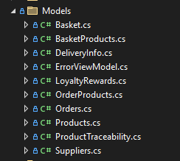
- Next, I scaffolded the models into controllers and views to generate the basic CRUD structure
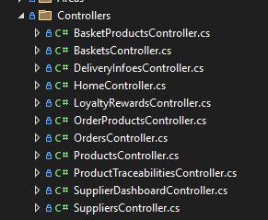
- Implemented SeedData to populate the database with initial users, roles, suppliers, and products for testing purpose
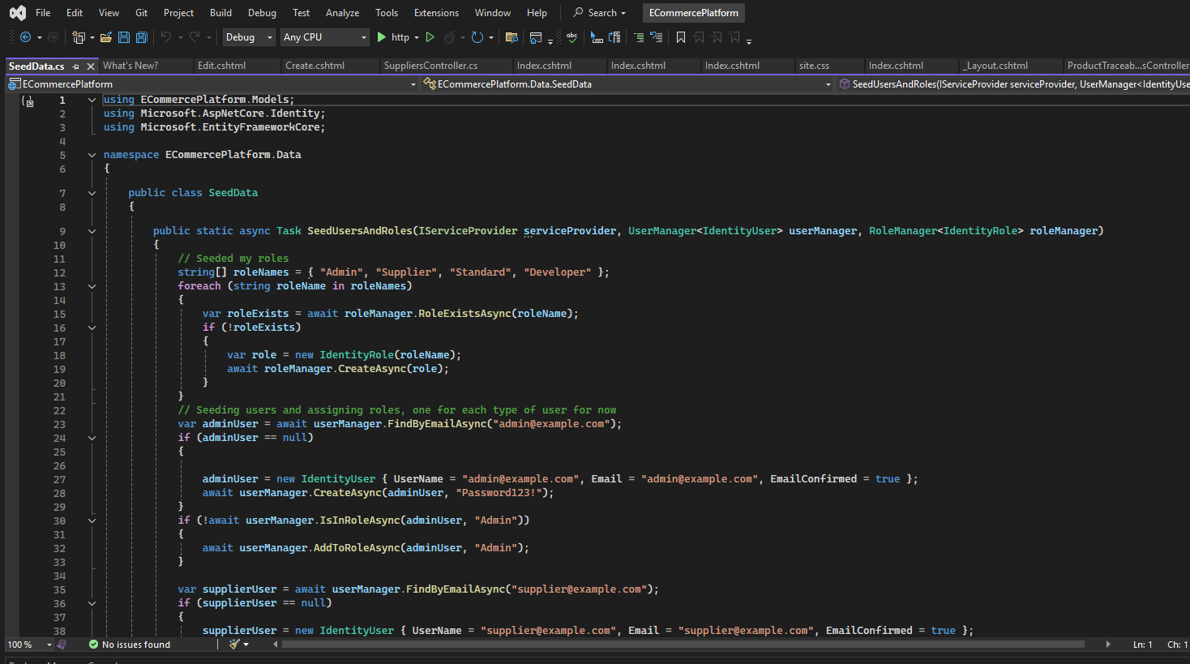

Tomorrow I will:
- Work on the controller and view
- Download images for the system
- Add a checkout system
- Add a google sign-in function
Day 2:
Today I:
- Improved controllers and views to ensure key system functions were working correctly
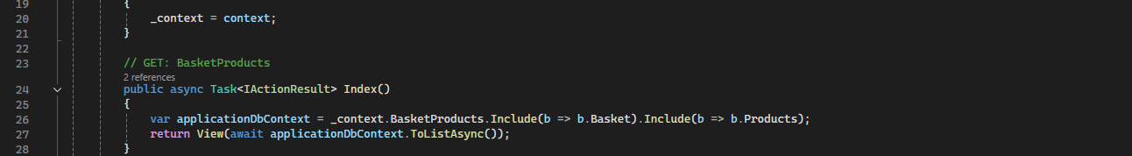
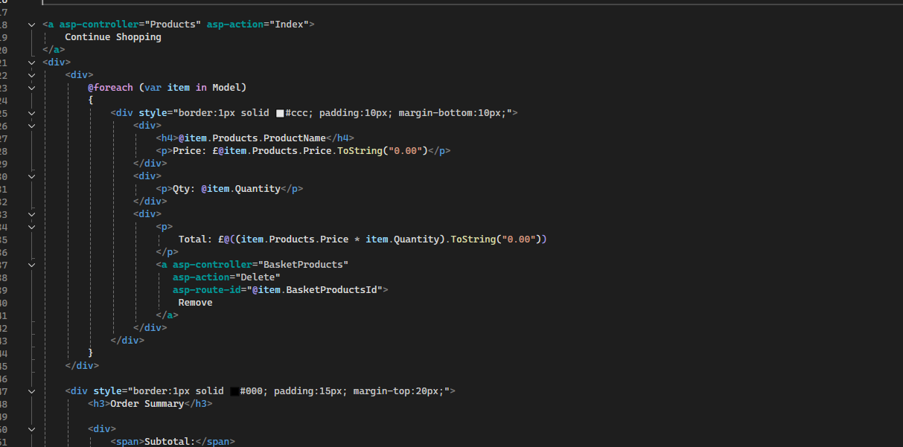

- Added and integrated products images into the application.
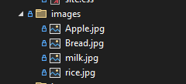
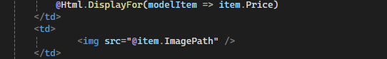
- Implemented a basic checkout functionality to allow users to place orders 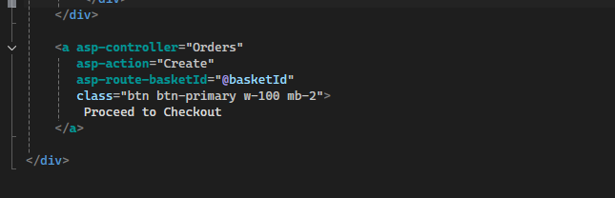
- Integrated Google Sign-in authentication to improve user accessibility and login options
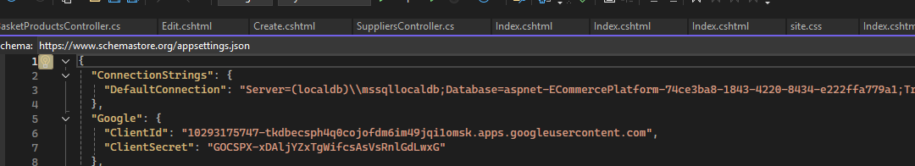
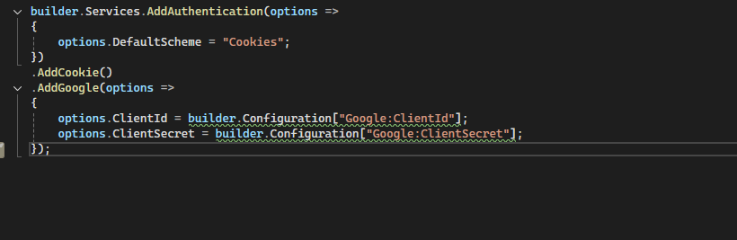
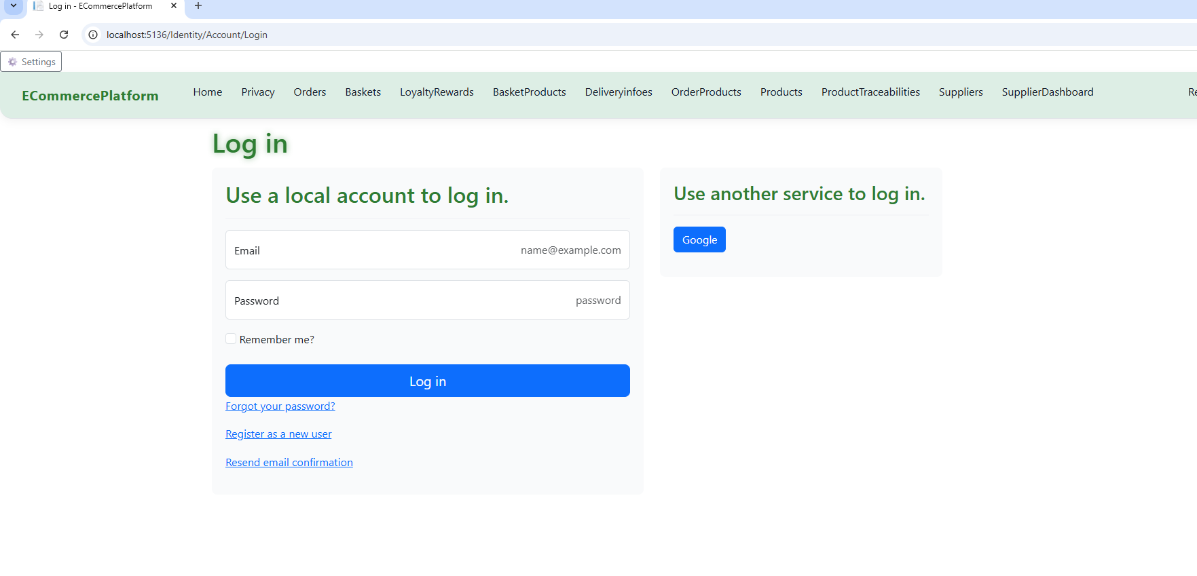
Tomorrow I Will:
- Work on the home Page
- Develop the Privacy Policy page
- Add a Supplier Dashboard to the system
Day 3:
Today I:
- Enhanced the home page by adding text content and interactive flip cards to improve visual appeal and professionalism
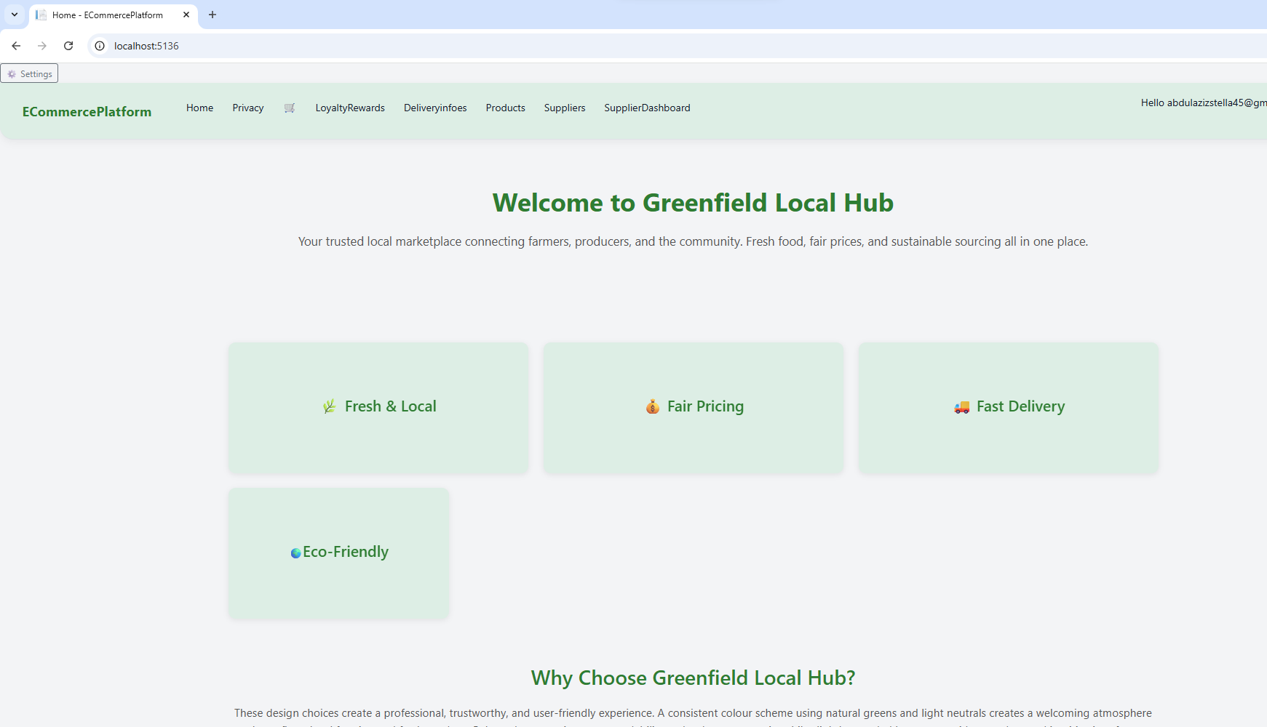
- Developed the privacy policy page, adding relevant company system information
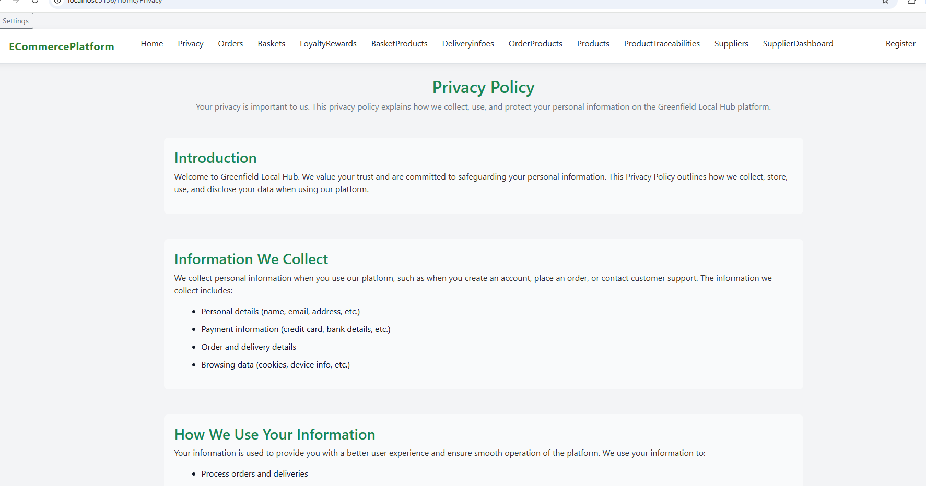

- Created a supplier dashboard controller and view
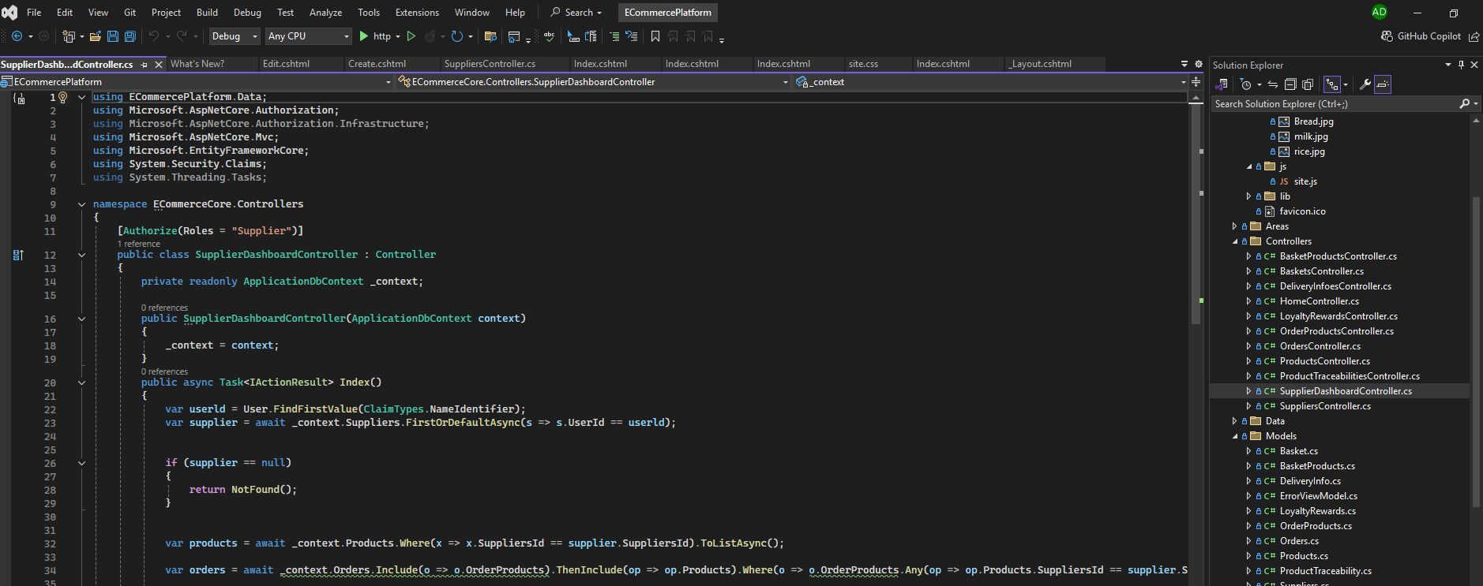
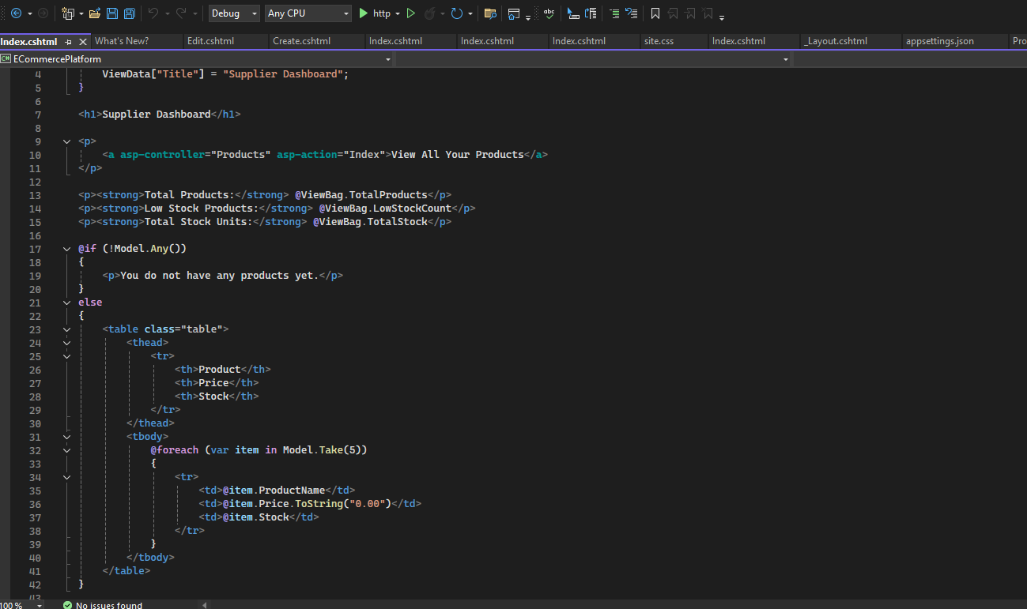

Tomorrow I Will:
- Improve and resize the footer for better layout consistency
- Further develop the product listing page
- Improve functionality of the basket page

Day 4:
Today I:
- Resized and improved the footer design for better user interface balance 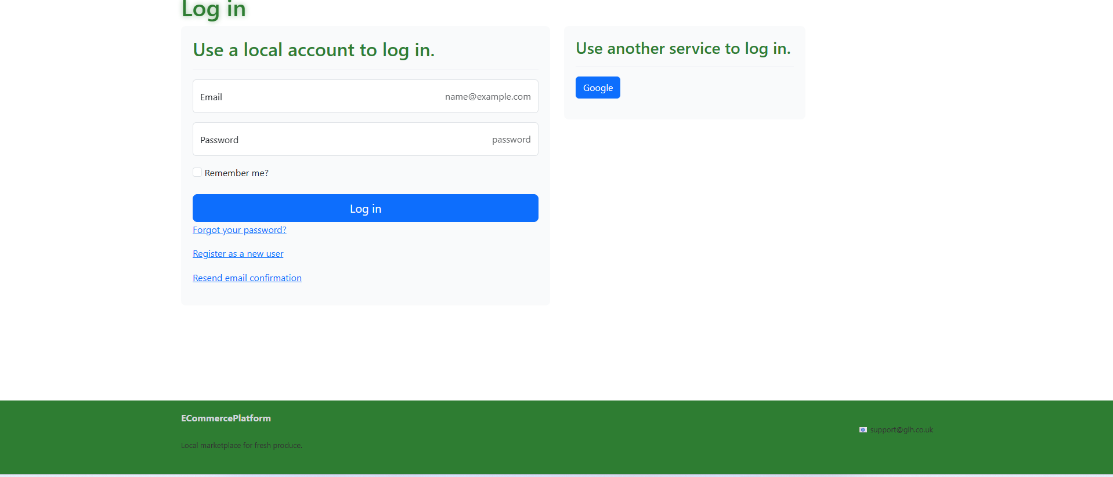
- Worked on improving the product page layout and usability

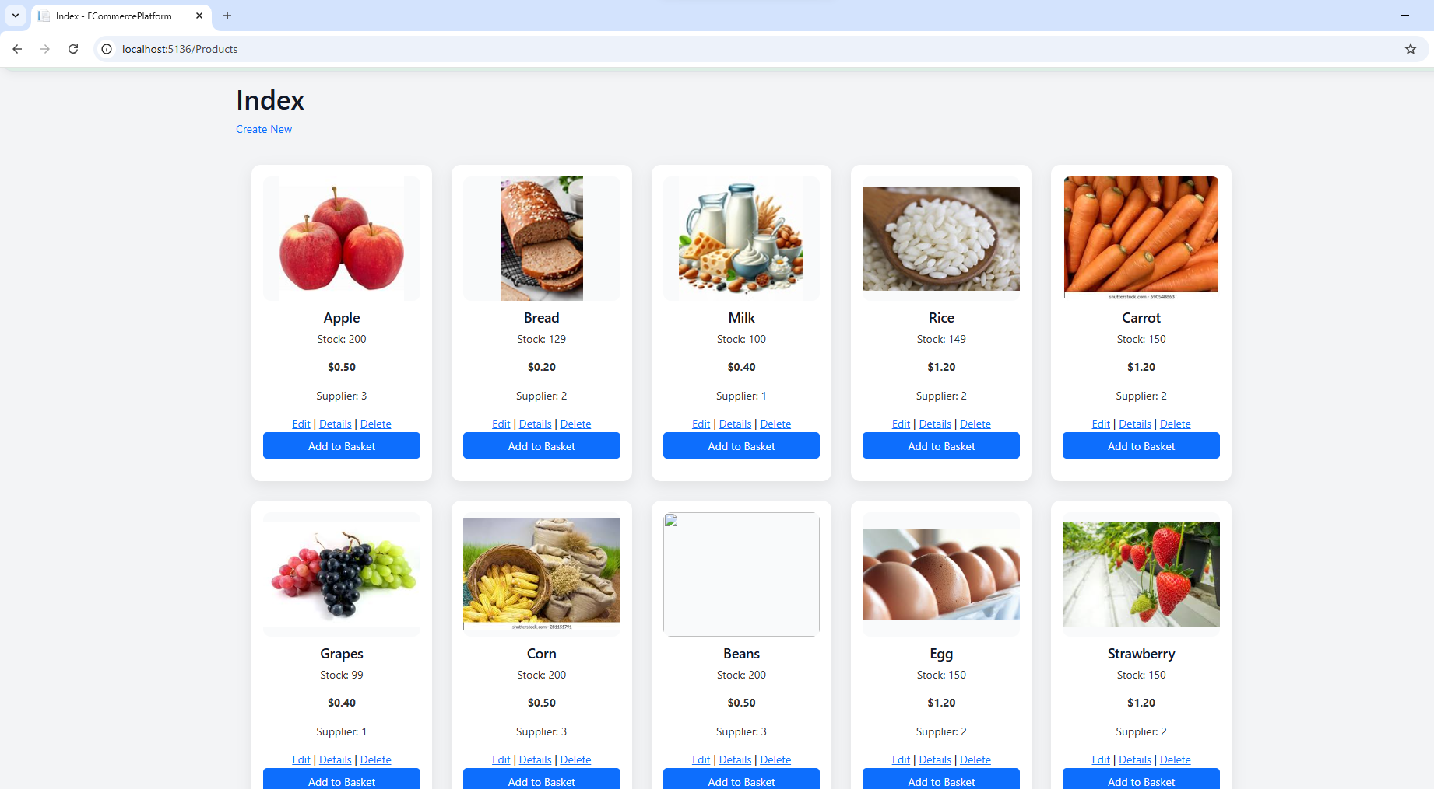

- Worked on the basket Page and also add an authorization function where you have to be logged in before you can view the basket
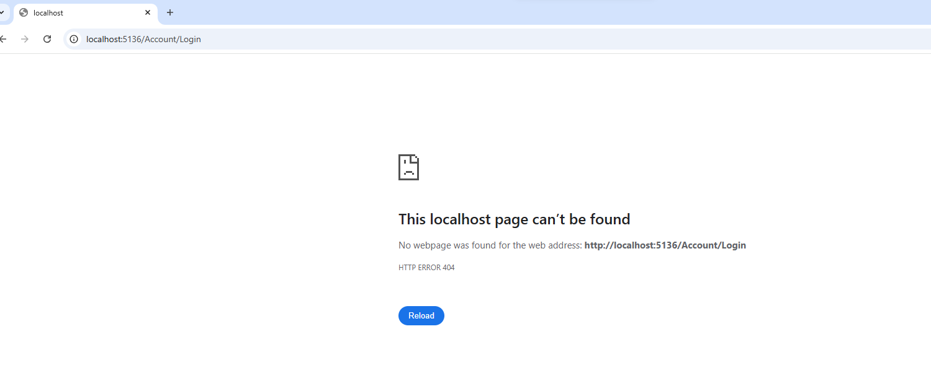
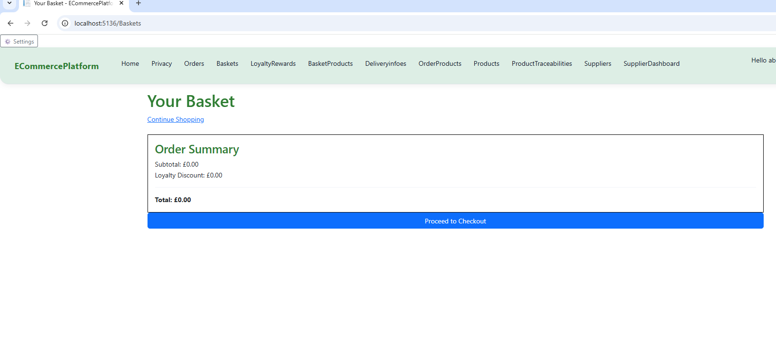
Tomorrow I will:
- Improve overall user experience features across the system.
- Develop the loyalty rewards page.
- Enhance basket product management functionality.
- Work on order product processing and display.
Day 5:
Today I:
- Added multiple usability improvements to make the system more user-friendly
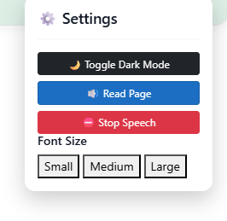
- Developed the loyalty rewards system to track user points and engagement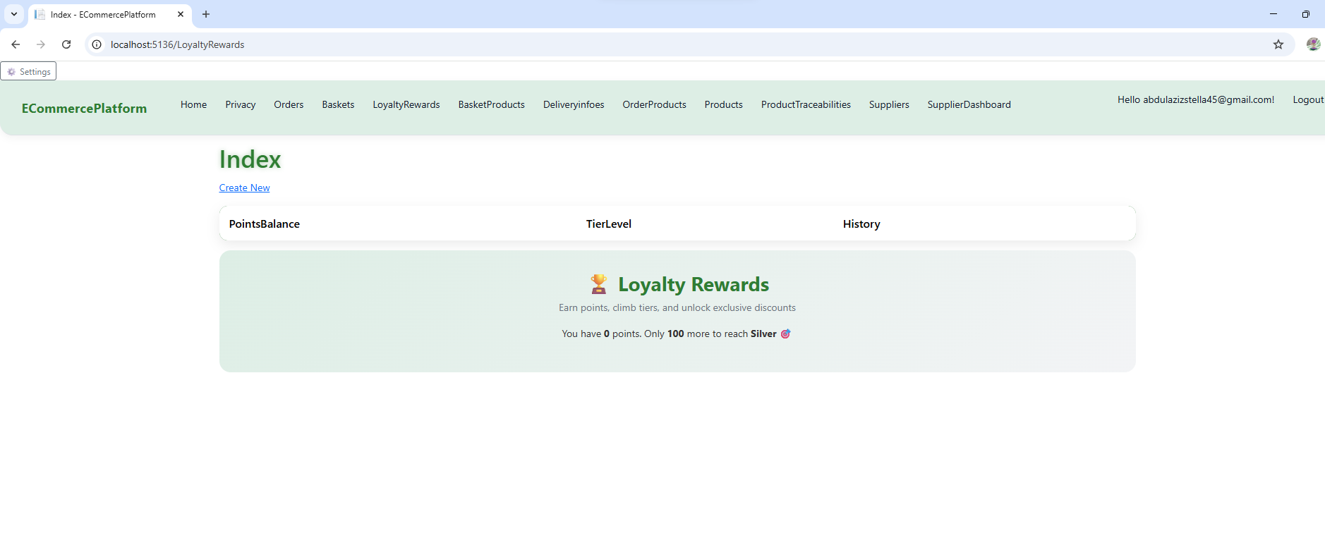
- Worked on the basket products page to improve item handling and display 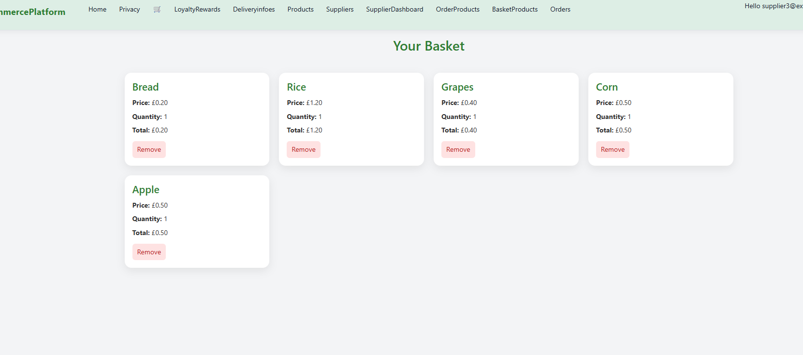

- Improved the order products page to enhance order tracking and structure
